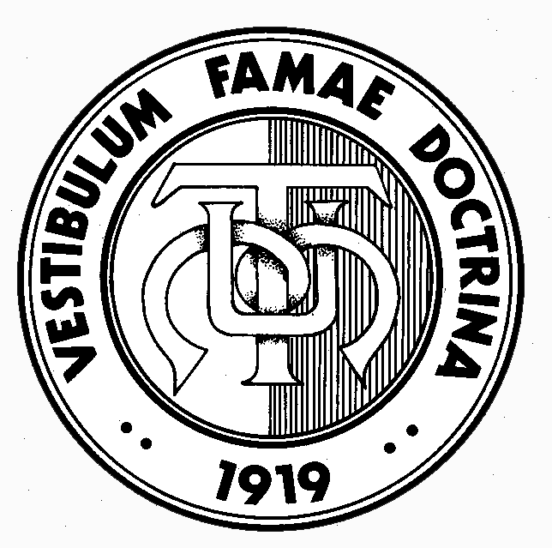

MALTA UNION OF TEACHERS
TEACHERS’ INSTITUTE, 759, Triq il-Kbira San Ġużepp, Ħamrun, ĦMR 1016
Tel: (356) 21237815, 21222663 • Fax: (356) 21244074
e-mail: info@mut.org.mt • Website: http//www.mut.org.mt

25th April 2017

MUT Triennial General Conference – 2017

The MUT Triennial General Conference will be held at on the 26th May 2017. The theme selected for the Conference is “The Challenges of Teacher Shortages and Precarious Employment in the EU, focus on Italy”.

The General Conference will be held at the Dolmen Hotel, Qawra. Speakers addressing this conference include the Mr. Claudio Franchi, General Secretary of CGIL Scuola and the MUT President.

Delegates/Observers for the MUT Triennial General Conference 2017

Nomination forms for the registration of Delegates/Observer are being enclosed with this circular. Members are kindly reminded that as per rule 13b (https://mut.org.mt/about/statute/) members have to be up to date in their subscription fees to be able to attend.

The Nomination Forms attached must reach the MUT Secretariat by the MONDAY 8th May 2017 in order to obtain the release from the various employers in adequate time frames.

Amendments to the MUT Statute and Motions for approval by the Triennial General Conference 2017

The MUT Statute provides that the MUT Council and MUT Delegates in Schools may present Amendments to Statute and Motions for approval by voting during the General Conference.

The Amendments to Statute and Motions of the MUT Council for the General Conference have been drafted and are being reproduced below. Delegates may propose Counter-Amendments to the Amendments and Motions being presented by Council.

Moreover, MUT Delegates may also wish to submit Amendments to Statute or Motions on behalf of their members at School.

Any counter-amendments, counter-motions as well as amendments and motions, signed by the School Delegate and seconded by MUT Committee/MUT members at the school are to reach the MUT Secretariat (info@mut.org.mt) by not later than the Monday 8th May 2017.

Kindly adhere to the deadline so as to facilitate the organizational process. The MUT Statute may be viewed on the website: www.mut.org.mt

MUT Council Amendments to Statute and Motions for approval of the General Conference 2017

Council Amendments to Statute

To amend Article 29 f (1)

DUTIES: It shall be the duty of the General Secretary:-
(i) At the bidding of the President to summon the Council by sending in good time a
notice to each member, including the Agenda for the meeting, and to take the
necessary and usual steps to summon a General Conference;

To Read:

DUTIES: It shall be the duty of the General Secretary:-
(i) At the bidding of the President to summon the Council by sending at least three working days before a notice to each member, including the Agenda for the meeting and Minutes of the preceeding meeting, and to take the necessary and usual steps to summon a General Conference;

Council Motions:

- Din il-Konferenza Ġenerali titlob li l-Kunsill tal-MUT jesplora l-modi ta’ kif l-istrutturi tal-MUT jiġu msaħħa b’mod li l-membri jħossuhom aktar rappresentati fid-deċiżjonijiet li jittieħdu.

- Il-Konferenza Ġenerali tappella li l-Kunsill tal-MUT għandu jisħaq mal-awtoritajiet sabiex fl-ingaġġ ta’ Supply LSAs jiġi assigurat li l-persuni kollha li ser jiġu ngaġati ikollhom tal-anqas il-kors ta’ għaxar ġimgħat qabel ma jiddaħħlu fl-impjieg.

Giovanni Curmi Higher Secondary School Delegates Motion:

Li fl-Iskola Giovanni Curmi l-MUT tiftaħ sezzjoni ghall-staff klerikali u anċillari sabiex ikun possibbli bdiet ta' assistenza li qed isiru lilna bħala Union ta' l-Ghalliema.

Franklin Barbara
General Secretary

